Installation of PKZIPC for use with GBSS 3.2.00

- When you purchase PKZIPC you will receive a file called pkzc400s.exe. Run this self-extracting zip file and you will see the following window:

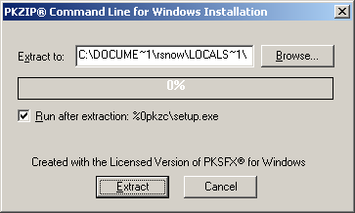

- After extracting you will see the following screen:

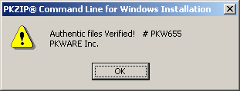

- Press OK and you will see:

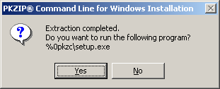

- Press Yes and you will see the following:

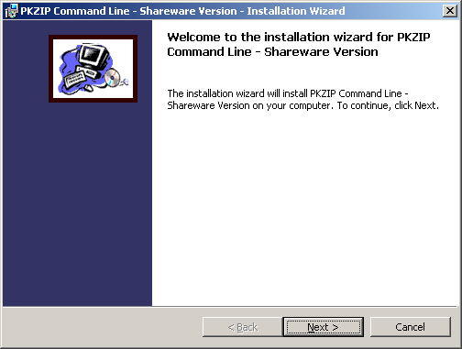

- Press Next

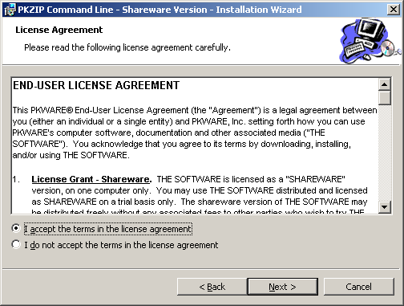

- Select “I accept…” and press Next

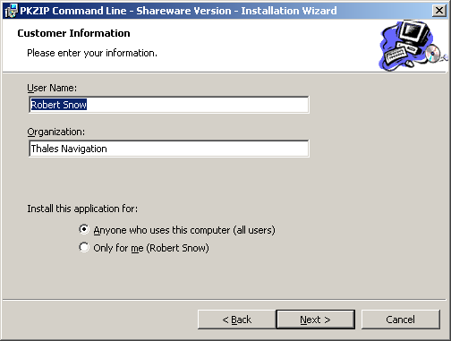

- Enter your User Name and company, select who can use the program and press next

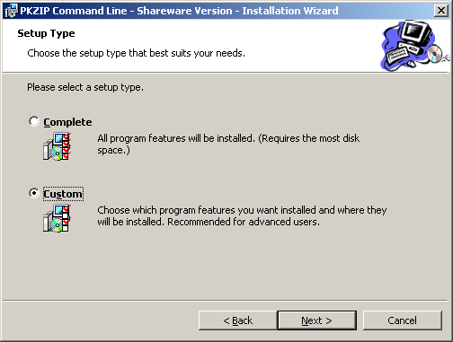

- Select “Custom” and press Next:

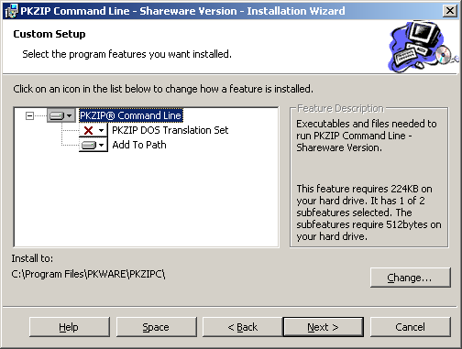

- VERY IMPORTANT: You must click on the RED X and choose “This feature will be installed on local hard drive”, then click Next
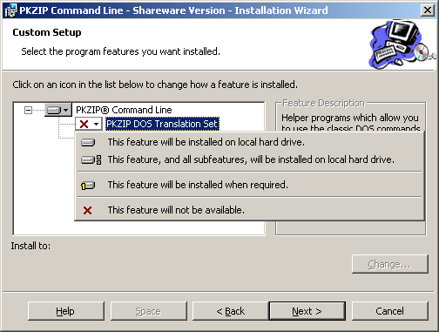

Your configuration screen should look like this:

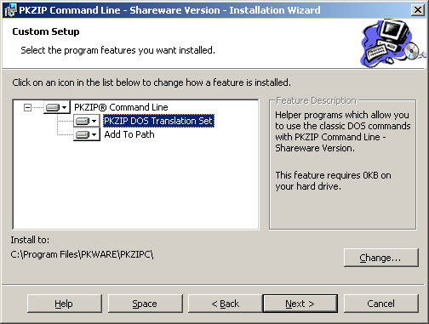

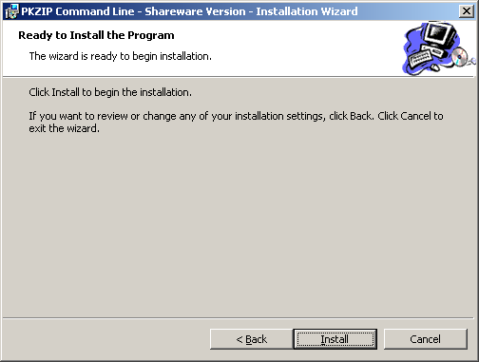

- Click Install to finish installation

